Introduction
Welcome
This course is designed for the person that wants to learn what it means to become or be a follower of Jesus. Many people that seek this knowledge realize that the Bible is where they must look, but have been hampered in their quest for one reason or another (e.g. intimidated by the size of the Bible, don’t know where to begin, tried to read the Bible but couldn’t make sense of it, got discouraged, etc.).
This is a self-directed study to assist you in your quest for answers. It is intended to take you rapidly through select books of the Bible to give you a “big picture” overview of what it means to be or become a follower of Jesus, and to become familiarized with the Bible——which is the definitive handbook for those who want to follow Jesus. For maximum benefit, plan on spending about 30 minutes every day for the next few weeks.
The course consists of two parts: the first covers the basics and can be completed in two weeks. The second part “digs deeper” into the Bible and takes an additional five weeks of daily reading. This study lays the basic foundation for understanding the Bible and what it means to be a follower of Jesus.
After completing this course, you will be equipped, empowered and excited to continue your study of the Bible.
The Non-Sequential Reading Approach
Most people that are new to the Bible approach it like any other book that they read——they start at the beginning and read linearly through to the end.
However, this often leads to frustration because a linear reading approach does not readily facilitate an understanding of the Bible as you are reading it. This course takes a different approach by taking you through books of the Bible in a non-sequential order. As such, this facilitates a greater understanding of the big picture of the Bible as you are reading it——that is, as you progress through the daily reading schedule, you will understand more and more what the Bible is saying.
Getting Started
You will need a Bible and a pencil or highlighter.
It is not necessary to buy a study version of the Bible for this course, but you may find it beneficial in the long term to start this course using a study Bible. If English is your native language, choose a modern Bible translation——NIV, NRSV, NASB, ESV and NKJV are all excellent choices——but avoid paraphrase versions for this study. (Paraphrase versions are excellent for getting a different perspective on a word in the original Greek or Hebrew text, but this type of study should be saved for later in your journey.)
The Importance of Daily Reading
Carve out time each day to complete the readings.
This course requires about 20-40 minutes of focused, uninterrupted daily reading. Every day before you begin reading, pray to God asking that the Holy Spirit would give you insight and understanding into what you are about to read.
Read the Bible selection as quickly as you can without skimming or speed reading (if you have a study Bible, do not stop to read the commentary notes, or do so only sparingly). If you notice a verse of interest, highlight it or underline it with a pencil, but do not stop to contemplate at this point in time yet (instructions will be given at the end of the course on how to read the Bible contemplatively and how to effectively use study Bibles and other commentaries).
It is important to read every day——missing a day or two will make it more difficult to remember where you left off and will also make it harder for you to develop a “big picture” view of the Bible.
The Bible at a Glance
The Bible consists of the Hebrew and Greek Scriptures.
The Hebrew Scriptures contain 39 books written by many different authors over a one thousand year period, between approximately 1400-400 BC. Except for a few sections, it is written entirely in Hebrew. A more detailed description of the Hebrew Scriptures is included later in this study, but for the purposes of this introduction, it is sufficient to summarize that the Hebrew Scriptures as a whole tell of a special and unique task that the Creator God gave to the descendants of a man named Abraham——the Israelites. The purpose of this task was that the Israelites were “commissioned” to tell all the other people of the world about the Creator God. The Hebrew Scriptures contain many references of the coming of a Messiah (which is the Hebrew word for savior or rescuer).
Image: Old Testament Structure and Timeline
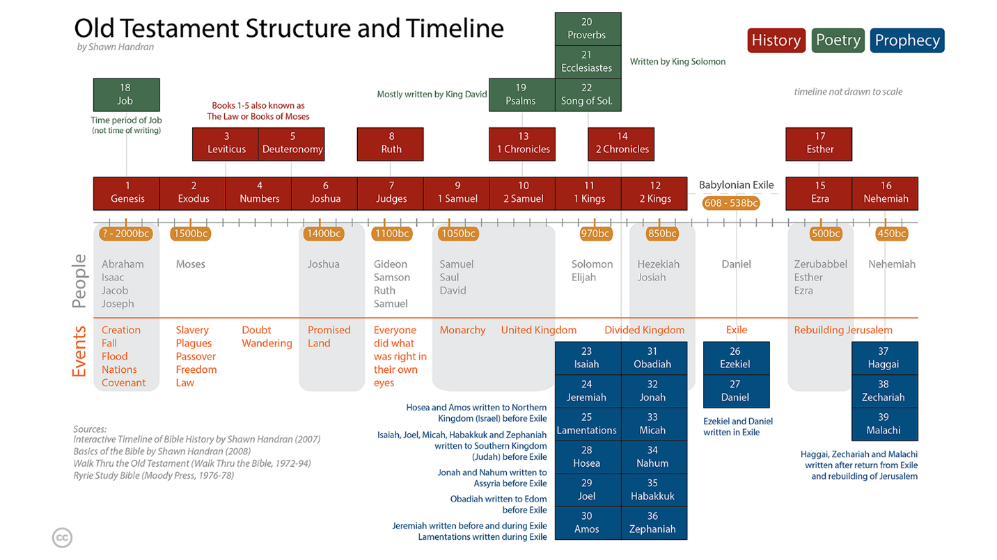
The Greek Scriptures contain 27 books, also written by several different authors over a period of approximately 50 years, around 40-90 AD. The Greek Scriptures show how the Creator God entered into history by becoming a human, fulfilling what was written in the Hebrew Scriptures about the coming Messiah (Savior). The Messiah is a descendant of Abraham named Yeshua (Joshua), or as translated in English: Jesus. The Greek word for Messiah is Christos, from which the title Christ is derived. Today, we put the name and title together: Jesus (the) Christ.
Image: New Testament Structure and Timeline
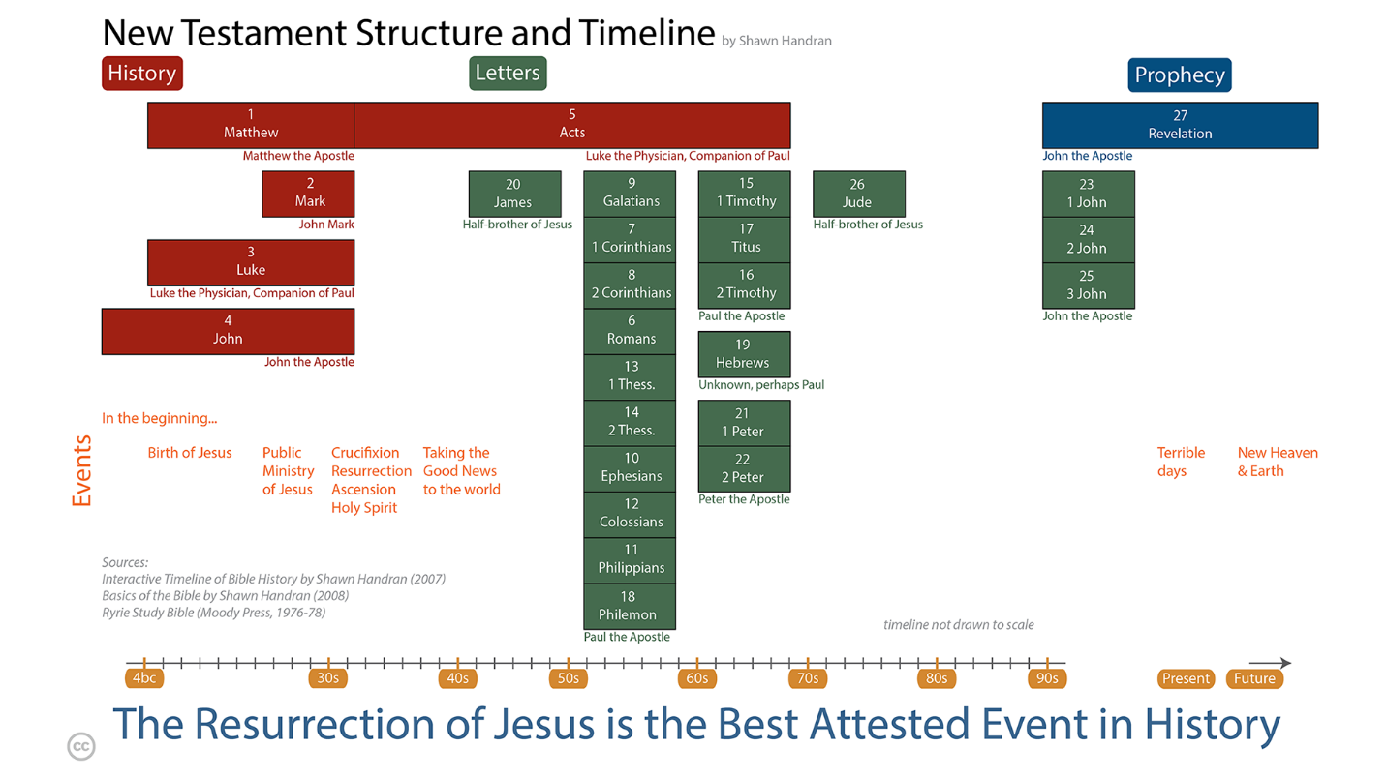
Navigating the Bible: Chapters and Verses
The Bible is numbered so that it is easy to navigate and find a particular passage.
Most of the books are divided into chapters (a few of the smallest books have a single un-numbered chapter), and each chapter in turn is divided into verses. A verse is typically one or two sentences. Even those that are unfamiliar with the Bible have probably heard someone quote or refer to John 3:16. This means the book of John, chapter 3, verse 16. When looking up books in the Bible, refer to the table of contents. In this example, the book of John, or the Gospel of John as it is known by its longer title, is located toward the back of the Bible. Once you locate John, flip through a couple of pages until you reach chapter 3. In most Bibles, the font size of the chapter number is much larger than the rest of the text whereas the verse number is a small superscript number embedded within the text itself. See examples:
Genesis 1:1 1¹In the beginning God created the heavens and the earth.
John 3:16 ¹⁶For God so loved the world that he gave his one and only Son, that whoever believes in him shall not perish but have eternal life.

簡介
歡迎
本課程專為那些想了解成為或作為耶穌跟隨者有何意義的人而設計。許多尋求這方面知識的人明白他們必須查考聖經，卻因著各種原因在探索的過程中受阻（例如：對聖經的厚度感到卻步、不知道從何讀起、試圖閱讀聖經卻看不懂、感到灰心等）。
這是一份自學指南，旨在協助您尋求答案。它的目的是帶您快速瀏覽精選的聖經書卷，為您提供一個「宏觀」的概覽，讓您了解作為或成為耶穌跟隨者的意義，並讓您熟悉聖經——這是想要跟隨耶穌之人的權威手冊。為了獲得最大的益處，請計劃在接下來的幾週內，每天花大約 30 分鐘的時間。
這門課程包含兩個部分：第一部分涵蓋基本內容，可以在兩週內完成。第二部分「深入探究」聖經，需要額外五週的每日閱讀。這項學習為理解聖經以及明白作耶穌跟隨者的意義奠定了基本根基。
完成這門課程後，你將會得到裝備、充滿力量並滿懷熱情地繼續研讀聖經。
非順序閱讀法
大多數初接觸聖經的人會像閱讀其他書一樣來讀它——他們從頭開始，然後按順序一直讀到最後。
然而，這通常會導致挫折，因為直線式閱讀法並不能輕易地幫助你在*閱讀的當下理解聖經。本課程採取了不同的方法，以非順序的方式帶領你讀過聖經各卷書。因此，這有助於你在閱讀時對聖經的全貌有更深入的理解*——也就是說，隨著你按著每日閱讀進度推進，你會越來越明白聖經在說什麼。
準備開始
你需要一本聖經，以及一枝鉛筆或螢光筆。
參加本課程不一定要購買研讀本聖經，但從長遠來看，使用研讀本聖經來開始本課程會對您有所幫助。如果英語是您的母語，請選擇現代的聖經譯本——NIV、NRSV、NASB、ESV 和 NKJV 都是極佳的選擇——但在進行本研經時，請避免使用意譯本。（意譯本對於從不同角度理解原文希臘文或希伯來文的字詞非常有幫助，但這種研讀方式應留待您日後的旅程中再進行。）
每日閱讀的重要性
請每天撥出時間來完成閱讀進度。
本課程需要大約 20-40 分鐘專注且 不間斷的每日閱讀。每天在開始閱讀之前，請向神禱告，求聖靈賜給你洞察力與悟性，以明白你即將閱讀的內容。
請 盡可能快速地 閱讀所選的聖經經文，但不要略讀或快速掃描（如果你使用的是研讀本聖經，請 不要停下來 閱讀註釋，或者盡量少看）。如果你注意到感興趣的經文，可以用螢光筆標記或用鉛筆畫線，但現在還不要停下來沉思（本課程結束時將會提供指導，教導如何默想式地閱讀聖經，以及如何有效使用研讀本聖經和其他註釋書）。
每天閱讀很重要——漏掉一兩天會讓你更難記住上次讀到哪裡，也會讓你更難建立對聖經的「宏觀」認識。
聖經速覽
聖經是由希伯來文和希臘文經卷所組成的。
希伯來聖經包含39卷書，由許多不同的作者在大約公元前1400至400年之間，歷經一千年的時間寫成。除了少數幾個段落外，全書都是用希伯來文寫成的。本研讀材料稍後將對希伯來聖經有更詳細的描述，但就本簡介的目的而言，只需概括說明：希伯來聖經整體上講述了創造主上帝交給一個名叫亞伯拉罕的後裔——以色列人——的一項特殊且獨特的任務。這項任務的目的是以色列人被「委任」向世界上所有其他人傳揚關於這位創造主上帝的事。希伯來聖經中包含了許多關於彌賽亞（即希伯來文中救主或拯救者之意）降臨的記載。
圖片：舊約結構與時間線
希臘文聖經包含27卷書，同樣由幾位不同的作者在約50年的時間裡寫成，大約在主後40至90年之間。希臘文聖經展示了造物主上帝如何藉著成為人進入歷史，應驗了希伯來文聖經中關於將要降臨的彌賽亞（救主）的記載。這位彌賽亞是亞伯拉罕的後裔，名叫 Yeshua（約書亞），或按英文翻譯為：耶穌（Jesus）。彌賽亞的希臘文是 Christos，基督這個頭銜即源於此。今天，我們將名字和頭銜放在一起：耶穌基督（Jesus the Christ）。
圖片：新約結構與時間線
查閱聖經：章與節
聖經經過編號，以便輕鬆查閱並找到特定的經文段落。
大多數的書卷被劃分為章（少數篇幅最短的書卷只有未編號的一章），而每一章又被劃分為節。一節通常是一兩個句子。即使是對聖經不熟悉的人，可能也聽過有人引用或提及約翰福音 3:16。這代表約翰福音，第3章，第16節。在查閱聖經書卷時，請參考目錄。在這個例子中，約翰這卷書（或者以其較長的書名被稱為《約翰福音》），位於聖經較後面的部分。一旦找到了《約翰福音》，翻幾頁直到第3章。在大多數的聖經版本中，章號的字體會比內文大很多，而節號則是嵌入在內文之中的微小上標數字。請看範例：
創世記 1:1 11起初，神創造天地。
約翰福音 3:16 16神愛世人，甚至將祂的獨生子賜給他們，叫一切信祂的，不致滅亡，反得永生。
一般來說，用你的第一語言能最好地理解聖經，因此如果你的母語有聖經譯本，請放心使用。如果你會兩種語言，請使用你最熟悉的語言。

Generally, you’ll understand the Bible best in your first language, so feel free to use that translation if it is available in your native tongue. If you are bilingual, use the language with which you are most comfortable

